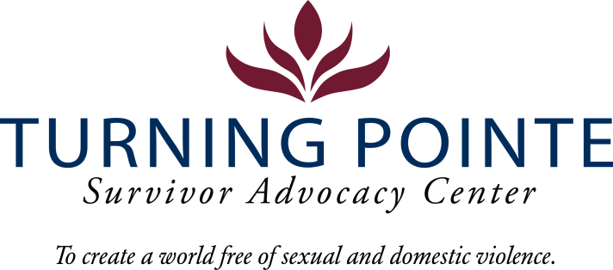

JOB DESCRIPTION
Job Title: Emergency Services Advocate (Shelter Advocate)
Job Location: Shelton/Mason County, WA
Reports to: Shelter Manger
Classification: Non-Exempt Full Time
Salary Range: $26/hour (Differential for Multi-language speaking)
Schedule: Friday – Sunday 8pm – 6am and Monday 11:30am – 2:30pm for Weekly Staffing Meeting (Days off: Tuesday, Wednesday, Thursday) Note: Schedule will vary occasionally to include holiday shifts (holiday payrate applies)

POSITION SUMMARY
The Emergency Services Advocate will respond to all hotline calls, provide safety plans and offer resources, conduct shelter screenings, and emergency intakes (police escort/request only) and provide emergency advocacy for shelter guests experiencing crisis. This position will accurately enter all client data as well as maintain all required paperwork and provide security checks. The Emergency Services Advocate is also responsible for stocking inventory, cleaning the crisis office, admin hall and staff kitchen, shelter bathrooms, laundry room, linen closet, and storerooms.

ESSENTIAL RESPONSIBILITIES, DUTIES AND TASKS
General Advocacy and Client Relations
- Remain knowledgeable about all Turning Pointe policies and procedures regarding client advocacy and shelter operations
- Maintain up-to-date knowledge of community resources that support the needs of Turning Pointe’s clients
- Provide excellent customer service
- Provide culturally appropriate and trauma-informed advocacy services by sharing community resource materials and referrals, and safety planning with Turning Pointe’s diverse clients.
- Assist in maintaining a safe, clean, and healthy shelter
- Accurately complete all required data entry and paperwork in a timely manner
Case Management
- Be mission and client focused when providing services
- Provide safety planning as needed for hotline callers

Minimum Qualifications
- Three years of customer service experience with a diverse range of people
- One year of client services, social work, advocacy, case management or DV/SA advocacy experience a plus
- GED or HS diploma required
- Ability to interact professionally with diverse clients, staff, community members, civic leaders, first responders and law enforcement
- Strong verbal communication skills
- High level of proficiency in Microsoft Word, Excel, PowerPoint, Outlook and other data management systems
- Ability to prioritize and multitask
- Ability to work a flexible schedule (including holidays), when needed, to support staffing requirements of 24/7 shelter

Education and Experience
- Maintains calm, caring and professional demeanor always, especially during stressful situations.
- Communicates effectively and appropriately in a diverse environment:
- Maintains confidentiality, discretion and professionalism by not discussing residents, guests, staff or clients with others
- Maintains proper client/staff relationship boundaries
- Treats all guests, residents, staff, clients and volunteers with respect and dignity regardless of race, ethnic background, gender or socioeconomic background

Physical Demands and Working Conditions
This position works in a fast-paced, crisis-oriented environment which can be emotionally taxing. Staff must always remain calm and often must deal with tense situations appropriately and immediately when interacting with clients, staff, community members, law enforcement and first-responders. Much of an Advocate’s time is spent providing face/face and phone-based client services as well as responding to individuals in crisis on hotline calls; time at a computer or performing other duties as needed is expected. The job often requires cleaning shelter rooms and moving personal belongings after a client leaves Turning Pointe. Employees must be able to lift or carry 15 – 30 pounds and push/pull 30 – 40 pounds. Position also requires being able to sit/stand for hours at a time.

Required Domestic Violence/Sexual Assault Advocate Core Training (Provided post-hiring)
- Minimum 80 hours of training and education
- 40-hour Sexual Assault Core (WCSAP Approved)
- 40-hour Domestic Violence Core (WSCADV Approved)
- Or similar dual DV/SA Core Training (WCSAP/WSCADV Approved)
- Ongoing training and education as required

BENEFITS
- Accrued paid time off (PTO), eligible upon date of hire
- Employer funded Simple IRA, eligible upon date of hire
- Employer funded life insurance policy, eligible upon date of hire
- Medical/Vision/Dental Insurance, monthly premium paid fully by employer
- One month paid sabbatical every three consecutive years of employment
- YMCA Membership

WA state background, fingerprinting and federal sex offender database checks are required for employment.

Employee Signature: ______________________________________ Date: ________________

Turning Pointe is an equal opportunity employer committed to workplace diversity. We do not discriminate in employment practices based on age, sex, marital status, sexual orientation, race, creed, color, national origin, citizenship or immigration status, honorably discharged veteran or military status, or the presence of any sensory, mental, or physical disability or the use of a trained dog guide or service animal by a person with disability. (RCW 49.60.200)

