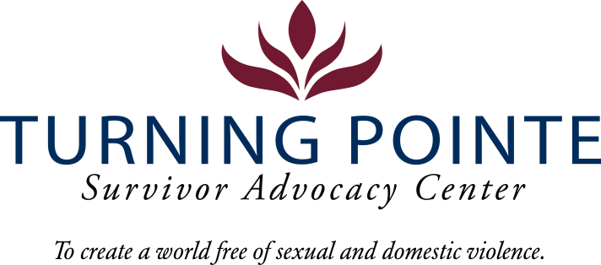

JOB DESCRIPTION
Job Title: Emergency Services Advocate (Shelter Advocate)
Job Location: Shelton/Mason County, WA
Reports to: Programs Director
Classification: Non-Exempt Full Time
Salary Range: $25/hour (Differential for Multi-language speaking)
Schedule: Friday – Sunday 12pm – 8:30pm and Monday 11:30am – 2:30pm for Weekly Staffing Meeting (Days off: Tuesday, Wednesday, Thursday) Note: Schedule will vary occasionally to include holiday shifts (holiday payrate applies)

POSITION SUMMARY
The Shelter Advocate plays a crucial role in providing comprehensive support to clients. This position involves conducting client screenings and intakes, offering both phone-based and in-person advocacy as needed, and supporting shelter residents. The Advocate will also provide remote assistance via phone-based advocacy and crisis hotline calls, offering referrals, information, and developing safety plans when appropriate. Additionally, this position requires performing general administrative tasks, including data entry, maintaining accurate records, and ensuring the cleanliness of shelter common areas and living spaces. The Advocate is responsible for managing a caseload and must work independently, complete projects, and meet client needs with minimal supervision.

ESSENTIAL RESPONSIBILITIES, DUTIES AND TASKS
General Advocacy and Client Relations
- Remain knowledgeable about all Turning Pointe policies and procedures regarding client advocacy and shelter operations
- Maintain up-to-date knowledge of community resources that support the needs of Turning Pointe’s clients
- Provide excellent customer service
- Provide culturally appropriate and trauma-informed advocacy services by sharing community resource materials and referrals, and safety planning with Turning Pointe’s diverse clients.
- Coordinate with Turning Pointe team and community members to enhance client support and services
- Assist in maintaining a safe, clean, and healthy shelter
- Accurately complete all required paperwork in a timely manner
- Perform daily room checks to ensure client compliance with shelter rules
- Coordinate with Fund Development Manager for in-kind donations

Case Management
- Be mission and client focused when providing services
- Conduct weekly case management sessions with clients to assess their needs, provide support, and ensure they have access to necessary resources
- Provide safety planning
- Develop individualized plans that address the unique circumstances and goals of each client
- Monitor client progress and adjust the case management plan as needed to ensure ongoing support and safety

Minimum Qualifications
- Three years of customer service experience with a diverse range of people
- One year of client services, social work, advocacy, case management or DV/SA advocacy experience a plus
- GED or HS diploma required
- Ability to interact professionally with diverse clients, staff, community members, civic leaders, first responders and law enforcement
- Strong verbal communication skills
- High level of proficiency in Microsoft Word, Excel, PowerPoint, Outlook and other data management systems
- Ability to prioritize and multitask
- Ability to work a flexible schedule (including holidays), when needed, to support staffing requirements of 24/7 shelter

Education and Experience
- Maintains calm, caring and professional demeanor always, especially during stressful situations.
- Communicates effectively and appropriately in a diverse environment:
- Maintains confidentiality, discretion and professionalism by not discussing residents, guests, staff or clients with others
- Maintains proper client/staff relationship boundaries
- Treats all guests, residents, staff, clients and volunteers with respect and dignity regardless of race, ethnic background, gender or socioeconomic background

Physical Demands and Working Conditions
This position works in a fast-paced, crisis-oriented environment which can be emotionally taxing. Staff must always remain calm and often must deal with tense situations appropriately and immediately when interacting with clients, staff, community members, law enforcement and first-responders. Much of an Advocate’s time is spent providing face/face and phone-based client services as well as responding to individuals in crisis on hotline calls; time at a computer or performing other duties as needed is expected. The job often requires cleaning shelter rooms and moving personal belongings after a client leaves Turning Pointe. Employees must be able to lift or carry 15 – 30 pounds and push/pull 30 – 40 pounds. Position also requires being able to sit/stand for hours at a time.

Required Domestic Violence/Sexual Assault Advocate Core Training (Provided post-hiring)
- Minimum 80 hours of training and education
- 40-hour Sexual Assault Core (WCSAP Approved)
- 40-hour Domestic Violence Core (WSCADV Approved)
- Or similar dual DV/SA Core Training (WCSAP/WSCADV Approved)
- Ongoing training and education as required

BENEFITS
- Accrued paid time off (PTO), eligible upon date of hire
- Employer funded Simple IRA, eligible upon date of hire
- Employer funded life insurance policy, eligible upon date of hire
- Medical/Vision/Dental Insurance, monthly premium paid fully by employer
- One month paid sabbatical every three consecutive years of employment
- YMCA Membership

WA state background, fingerprinting and federal sex offender database checks are required for employment.

Employee Signature: ______________________________________ Date: ________________

Turning Pointe is an equal opportunity employer committed to workplace diversity. We do not discriminate in employment practices based on age, sex, marital status, sexual orientation, race, creed, color, national origin, citizenship or immigration status, honorably discharged veteran or military status, or the presence of any sensory, mental, or physical disability or the use of a trained dog guide or service animal by a person with disability. (RCW 49.60.200)

