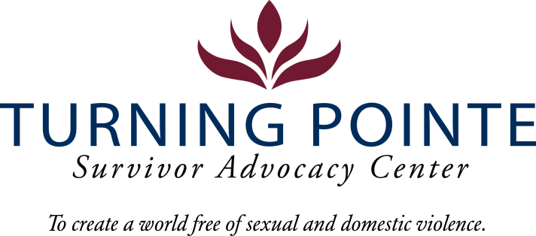

INTERNSHIP DESCRIPTION

Job Title: Support Group Facilitation Intern
Job Location: Shelton
Reports to: Community Resources Advocate
Classification: Internship (Unpaid)
Schedule: Schedule will vary based on agency needs but may include a commitment from 50-400 hours over a 10-week quarter
POSITION SUMMARY

Turning Pointe provides safety and support for survivors through advocacy, prevention education, and action for social change. With 56 beds, Turning Pointe operates the largest domestic violence shelters in the state. We are seeking a Support Group Facilitation Intern to help build meaningful, supportive relationships with shelter guests as well as housing and non-residential clients to enhance their ability to process trauma and progress toward goals through connection with people facing similar challenges, for shared experience, emotional support, practical advice, and reduced isolation, while promoting coping skills, building hope and developing resilience through community.

Essential Responsibilities, Duties and Tasks

- Remain knowledgeable about all Turning Pointe policies and procedures regarding client advocacy and shelter operations
- Model and promote Turning Pointe’s values, including kindness, respect, resilience and responsibility
- Facilitate and assist with enrichment activities and topics for discussion fostering an atmosphere of participation, active listening and reflection
- Provide culturally appropriate and trauma-informed discussions and engagement, collaborating with staff, to ensure safe, inclusive and welcoming environment
- Accurately complete all required paperwork in a timely manner
What you can Expect
- Be a part of a dynamic and passionate team of professionals that are committed to improving our community
- Gain valuable experience and confidence in your field
- Explore a new career path
- Develop and refine your skills to enhance your qualifications for future opportunities
- Obtain an understanding of the type of working environment, field and industry that align with your career goals
- Mentorship from experienced professionals in education and nonprofit work.
- Enhanced skills in communication, leadership, problem-solving, and teamwork.
- A deeper understanding of equity, service, and community resilience.
Please submit a letter of interest and resume to Mallory Cloninger, Programs Director at Turning Pointe at programs@turningpointe.org

