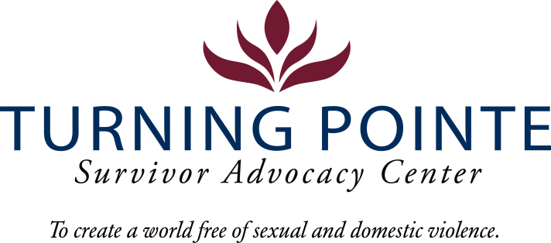

INTERNSHIP DESCRIPTION

Job Title: Marketing and Social Media Intern
Job Location: Shelton
Reports to: Development Director
Classification: Internship (Unpaid)
Schedule: Schedule will vary based on agency needs but may include a commitment from 50-400 hours over a 10-week quarter

POSITION SUMMARY

Turning Pointe provides safety and support for survivors through advocacy, prevention education, and action for social change. With 56 beds, Turning Pointe operates the largest domestic violence shelters in the state. We are seeking a marketing/communications professional with demonstrated experience publishing engaging content to educate and mobilize our online community.

Essential Responsibilities, Duties and Tasks

- Obtain working knowledge about operations, initiatives and communicate effectively Turning Pointe programming
- Maintain messaging strategies like video, graphic and written storytelling that further Turning Pointe’s mission
- Ability to monitor Turning Pointe’s social space, be responsive and courteous to online engagement from viewers and notify management when topics of concern arise
- Provide culturally appropriate and trauma-informed messaging, resource materials and content development
- Implementing strategies to help grow, engage and retain followers on our online platforms utilizing storytelling mediums that highlight how Turning Pointe benefits our community
- Must be currently enrolled in a communications, public relations, digital media or similar course of study
- Capable of doing research on monthly areas of focus that relate to our DV and SA work, (for example: Human Trafficking Awareness Month, DV awareness month etc.) and tailor messages and posts to spread awareness or educate on Turning Pointe’s commitment to these efforts
- A creative thinker who loves to brainstorm or learn new and exciting social media trends, has a passion for creating content, and is eager to learn more about the ever-changing social media space

What you can Expect
- Be a part of a dynamic and passionate team of professionals that are committed to improving our community
- Gain valuable experience and confidence in your field
- Explore a new career path
- Develop and refine your skills to enhance your qualifications for future opportunities
- Obtain an understanding of the type of working environment, field and industry that align with your career goals
- Mentorship from experienced professionals in education and nonprofit work.
- Enhanced skills in communication, leadership, problem-solving, and teamwork.
- A deeper understanding of equity, service, and community resilience.
Please submit a letter of interest and resume to Mallory Cloninger, Programs Director at Turning Pointe at programs@turningpointe.org

