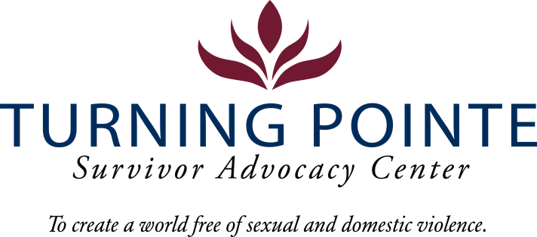

INTERNSHIP DESCRIPTION

Job Title: Community Impact Intern
Job Location: Shelton
Reports to: Development Director
Classification: Internship (Unpaid)
Schedule: Schedule will vary based on agency needs and Intern schedule but may include a commitment from 50-400 hours over a 10-week quarter
POSITION SUMMARY

Turning Pointe provides safety and support for survivors through advocacy, prevention education, and action for social change. With 56 beds, Turning Pointe operates the largest domestic violence shelters in the state. We are seeking a Young Professional/Community Impact Intern who can grow Turning Pointe’s network and visibility in the region to educate the community about our mission and impact.

Essential Responsibilities, Duties and Tasks

- Model and promote Turning Pointe’s values, including kindness, respect, resilience and responsibility
- Build Turning Pointe’s network and community presence through attendance at local meetings, gatherings and other appropriate events to share about Turning Pointe activities and impact
- Participate in local Chamber of Commerce events, non-profit, educational or volunteer events to connect with local groups for networking, leadership, community service and civic engagement
- Establish a Young Professional’s membership group to promote DV/SA advocacy educational events, advocate for legislative bills and funding to maintain protections for violence against women and children
What you can Expect
- Be a part of a dynamic and passionate team of professionals that are committed to improving our community
- Gain valuable experience and confidence in your field
- Explore a new career path
- Develop and refine your skills to enhance your qualifications for future opportunities
- Obtain an understanding of the type of working environment, field and industry that align with your career goals
- Mentorship from experienced professionals in education and nonprofit work
- Enhanced skills in communication, leadership, problem-solving, and teamwork
- A deeper understanding of equity, service, and community resilience
Please submit a letter of interest and resume to Mallory Cloninger, Programs Director at Turning Pointe at programs@turningpointe.org

