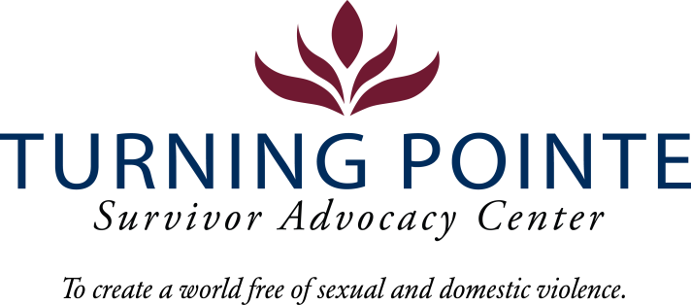
JOB DESCRIPTION
Job Title: Legal Advocate
Job Location: Shelton
Reports to: Program Director
Classification: Non-Exempt Full Time
Salary Range: $17.50 - $19.50 hour (DOQ)

Schedule: Proposed: 8:00 am – 4:30 pm Monday - Friday (attendance at Thursday staff meetings, 2:30 pm – 4:30 pm in Shelton offices is required). Note: Schedule will vary occasionally to include holiday shifts (holiday payrate applies).

BENEFITS
- Accrued paid time off (PTO), eligible upon date of hire
- Employer funded Simple IRA, eligible upon date of hire
- Employer funded life insurance policy, eligible upon date of hire
- Medical/Vision/Dental Insurance, fully paid by employer
- Employer funded Health Savings Account (HSA)
- Paid 11 holidays and one personal day
- Mileage reimbursement for work-required travel beyond typical commute
- YMCA Membership

WA state background, fingerprinting, and, federal sex offender database checks are required for employment.

Founded in 2001, Turning Pointe’s mission is to provide safety and support for survivors through advocacy, prevention education and action for social change. Our Advocates work with over 500 adult and youth survivors of domestic and sexual violence every year in our Shelton and Belfair, WA locations. We serve all survivors – we do not discriminate on the basis of gender identification, age, race, ethnicity, religion, marital status, nationality, disability or immigration status.

We place a high priority on the career development and wellness of every Turning Pointe team member. Employee recognition awards, staff retreats, celebratory potlucks, self-care activities and opportunities to grow professionally through special project assignments, expanded job responsibilities, conferences and training sessions are an important part of our culture.

POSITION SUMMARY
Position provides legal advocacy to survivors of domestic violence (DV) and sexual assault (SA), works with Turning Pointe’s legal program partners, law enforcement, CPS and the county’s legal systems community to assist in ensuring culturally appropriate legal resources are available for clients. Performs crisis intervention and ongoing advocacy in person and over the phone, assists with legal documents and accompanies clients to legal proceedings, when appropriate. Works closely with Turning Pointe’s team of Advocates to provide DV/SA survivors with advocacy services in a culturally appropriate and time sensitive manner. This position also performs general administrative, recordkeeping duties, and, completes timely and accurate data management. Cleaning shelter and office common areas and living spaces and other tasks are required as assigned.

Turning Pointe Competencies
- Communication: Expresses ideas effectively in writing and verbally; shares ideas and information with others proactively; organizes and delivers information appropriately; style and content of communication is audience-specific; actively and empathetically listens.
- Teamwork: Interacts with people effectively; able and willing to share and receive information; cooperates within groups and across groups; supports group decisions and puts group goals ahead of own goals.
- Initiative: Generates innovative ideas for improvement and problem-solving; practices self-development; does more than required and takes advantage of new opportunities.
- Sense of urgency: Prioritizes responsibilities of role appropriately; demonstrates enthusiasm and energy in approaching job; consistently meets or exceeds goals; maintains high level of productivity and self-direction.

ESSENTIAL RESPONSIBILITIES, DUTIES AND TASKS

Administration and Grant Reporting
- Remaining knowledgeable of all Turning Pointe policies and procedures regarding client advocacy
- Maintaining current knowledge on community resources that support the needs of Turning Pointe’s clients
- Completing and managing appropriate forms and files to ensure InfoNet and HMIS data entry is timely and accurate for all client services, per all grant compliance requirements
- Supporting the completion all reports, per monthly/quarterly/year-end grant requirements
- Assisting in shelter cleanliness, organization and donation sorting
Advocacy, Client Relations and Outreach
- Provide legal advocacy to clients, attend legal proceedings with clients if appropriate, and provide proper preparation support for courtroom activities
- Provide legal advocacy to clients in meetings with attorneys, law enforcement, prosecutors, public defenders, court personnel and local, tribal, state, military and other social service agency personnel
- Assist clients in procuring protection, restraining and/or anti-harassment orders
- Assist clients in gathering information for divorce, separation, child custody, visitation and parenting plans
- Maintain current knowledge about legal processes and paperwork that is relevant for clients
- Providing culturally appropriate advocacy support, resource materials and safety planning for Turning Pointe’s diverse clients as needed
- Recommending policies and or procedures to increase client safety, shelter housing, client confidentiality and advocate services, coordinating with advocates and team members to enhance client support and services
- Participate in strategic community outreach initiatives, as required, to generate awareness about Turning Pointe and represent the organization, per grant requirements

Education and Experience
- GED or HS diploma required
- Associate’s degree or higher in social work or related field, a plus
- Two years community service, social work or legal DV/SA advocacy experience, a plus

Minimum Qualifications
- Valid driver’s license and state required minimum automobile insurance coverage
- Ability to travel independently, as needed, for professional events and work tasks
- Current COVID-19 Vaccination Record Card
- Ability to interact professionally with diverse clients, staff, community members, civic leaders, first responders and law enforcement
- Strong verbal communication skills
- High level of proficiency in Microsoft Word, Excel, PowerPoint, Outlook and other data management systems
- Ability to prioritize and multitask
- Ability to work a flexible schedule (including holidays), when needed, to support staffing requirements of 24/7 shelter

Physical Demands and Working Conditions
This position works in a fast-paced, crisis-oriented environment which can be emotionally taxing. Staff must always remain calm and often must deal with tense situations appropriately and immediately when interacting with clients, staff, community members, law enforcement and first-responders. Much of an Advocate’s time is spent providing face/face and phone-based client services as well as responding to individuals in crisis on hotline calls; time at a computer or performing other duties as needed is expected. The job often requires cleaning shelter rooms and moving personal belongings after a client leaves Turning Pointe. Employees must be able to lift or carry 15 – 30 pounds and push/pull 30 – 40 pounds. Position also requires being able to sit/stand for hours at a time.

Required Domestic Violence/Sexual Assault Advocate Core Training (Provided by Turning Pointe post-hiring)
- Minimum 50 hours of training and education
  - 30-hour Sexual Assault Core (WCSAP Approved)
  - 20-hour Domestic Violence Core (WSCADV Approved)
  - Or similar dual DV/SA Core Training (WCSAP/WSCADV Approved)

Employee Signature: ______________________________________ Date:

Turning Pointe is an equal opportunity employer committed to workplace diversity. We do not discriminate in employment practices based on age, sex, marital status, sexual orientation, race, creed, color, national origin, citizenship or immigration status, honorably discharged veteran or military status, or the presence of any sensory, mental, or physical disability or the use of a trained dog guide or service animal by a person with disability. (RCW 49.60.200)

