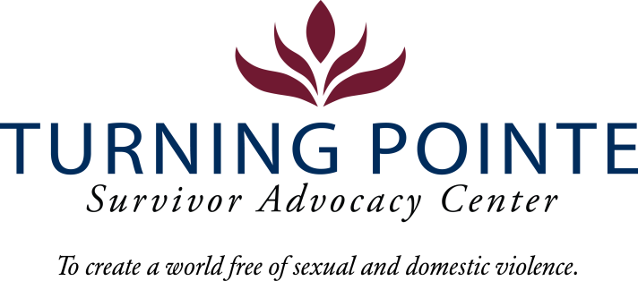
POSITION DESCRIPTION
Job Title: Youth Advocate
Job Location: Shelton
Reports to: Youth and Prevention Manager
FLSA Status: Non-Exempt Full Time
Salary Range: $17.50 – 19.50/hour (DOQ)

Schedule: Proposed: 9:30 am – 6:00 pm Monday – Friday

Attendance at Thursday staff meetings, 2:30 pm – 4:30 pm, in Shelton offices is required.

Note: Schedule will vary occasionally to support events/trainings. Occasional evening and weekend work required.

BENEFITS
- Accrued paid time off (PTO), eligible upon date of hire
- Employer funded Simple IRA, eligible upon date of hire
- Employer funded life insurance policy, eligible upon date of hire
- Medical/Vision/Dental Insurance, fully paid by employer
- Employer funded Health Savings Account (HSA)
- Paid 11 holidays and one personal day
- Mileage reimbursement for work-required travel beyond typical commute
- YMCA Membership

WA state background, fingerprinting, and, federal sex offender database checks are required for employment.

Founded in 2001, Turning Pointe’s mission is to provide safety and support for survivors through advocacy, prevention education and action for social change. Our Advocates work with over 500 adult and youth survivors of domestic and sexual violence every year in our Shelton and Belfair, WA locations. We serve all survivors – we do not discriminate on the basis of gender identification, age, race, ethnicity, religion, marital status, nationality, disability or immigration status.

We place a high priority on the career development and wellness of every Turning Pointe team member. Employee recognition awards, staff retreats, celebratory potlucks, self-care activities and opportunities to grow professionally through special project assignments, expanded job responsibilities, conferences and training sessions are an important part of our culture.

POSITION SUMMARY
The Youth Advocate is responsible for providing advocacy services to youth living in Turning Pointe’s shelter, accessing walk-in services at Turning Pointe, and completing forensic and medical exams at the local Child Advocacy Center. While the Youth Advocate will serve youth of all ages, the primary focus is on children birth to 12-years-old. The purpose of youth advocacy is to elevate the voices of young survivors by promoting self-determination and autonomy, to provide youth with a safe, consistent, and nurturing space to learn and grow, and to partner with families to ensure that children and young people who have been exposed to violence have access to the resources and support that they need to thrive. This work relies on strong community partnerships and requires a trauma-informed, culturally-relevant, strengths-based, and developmentally appropriate approach to working with youth.
Additionally, the youth advocate works to create fun and engaging opportunities for youth to play, learn, grow, and take a break from the stress created by exposure to domestic and sexual violence. These opportunities include art, gardening, help with school work, family events, and more!
Turning Pointe Competencies
- Communication: Expresses ideas effectively in writing and verbally; shares ideas and information with others proactively; organizes and delivers information appropriately; style and content of communication is audience-specific; actively and empathetically listens.
- Teamwork: Interacts with people effectively; able and willing to share and receive information; cooperates within groups and across groups; supports group decisions and puts group goals ahead of own goals.
- Initiative: Generates innovative ideas for improvement and problem-solving; practices self-development; does more than required and takes advantage of new opportunities.
- Sense of urgency: Prioritizes responsibilities of role appropriately; demonstrates enthusiasm and energy in approaching job; consistently meets or exceeds goals; maintains high level of productivity and self-direction.

ESSENTIAL RESPONSIBILITIES, DUTIES AND TASKS

Youth Advocacy
- Provide trauma-informed, culturally-relevant, and youth-center advocacy services for children and youth impacted by domestic or sexual violence
- Provide mobile medical/legal advocacy when needed to respond to child sexual abuse cases
- Engage youth in shelter through shelter tours, outreach, and activities/events
- Partner with youth’s families, when appropriate, to provide comprehensive care
- Plan and lead social/emotional educational groups for children, youth, and families
- Assist with other youth & prevention programs, including parenting class, summer programs, and prevention programs for youth

Youth Outreach
- Assist in efforts to build relationships with schools and youth-serving organizations
- Attend youth-focused community events to share information about youth services and connect with youth
- Partner with key youth serving organizations to create a network of support for youth, including Safe & Sound Child Advocacy Center, Catholic Community Services Wrap-around with Intensive Services program, Child Protective Services, schools, childcare centers, and other community-based organizations

Administration and Data Entry
- Remain knowledgeable of all Turning Pointe policies and procedures regarding client advocacy
- Maintain current knowledge on community resources that support the needs of Turning Pointe’s clients
- Complete and manage appropriate forms and files to ensure InfoNet, HMIS, and Youth data entry is timely and accurate for all client services, per all grant compliance requirements
- Assist with data entry and grant reporting for youth & prevention programs

Education and Experience
- GED or HS diploma required
- One year of experience working with children, youth, or families required
- Associate’s degree or higher in social work, child development, or related field, a plus
- Two years community service, social work or DV/SA advocacy experience, a plus

Minimum Qualifications
- Valid driver’s license and state required minimum automobile insurance coverage
- Ability to travel independently, as needed, for professional events and work tasks
- Current COVID-19 Vaccination Record Card
- Ability to interact professionally with diverse adult, children and youth clients, staff, community members, civic leaders, first responders and law enforcement
- Strong verbal communication skills
- Ability to lead groups and activities for diverse children and youth populations
- Basic proficiency in Microsoft Word, Excel, PowerPoint, Outlook, Canva and other data management systems
- Ability to prioritize and multitask
- Ability to work a flexible schedule (including holidays), when needed, to events, programs, and support staffing requirements of 24/7 shelter

Physical Demands and Working Conditions
This position works in a fast-paced, crisis-oriented environment which can be emotionally taxing. Staff must always remain calm and often must deal with tense situations appropriately and immediately when interacting with clients, staff, community members, law enforcement and first-responders. Much of an Advocate’s time is spent providing face/face and phone-based client services as well as responding to individuals in crisis on hotline calls; time at a computer or performing other duties as needed is expected. The job often requires cleaning shelter rooms and moving personal belongings after a client leaves Turning Pointe. Employees must be able to lift or carry 15 – 30 pounds and push/pull 30 – 40 pounds. Position also requires being able to sit/stand for hours at a time. Ability to transport clients as needed using the company van.

Required Domestic Violence/Sexual Assault Advocate Core Training (Provided by Turning Pointe post-hiring)
- Minimum 50 hours of training and education
  - 30-hour Sexual Assault Core (WCSAP Approved)
  - 20-hour Domestic Violence Core (WSCADV Approved)
  - Or similar dual DV/SA Core Training (WCSAP/WSCADV Approved)

Employee Signature: ______________________________________ Date:
Turning Pointe is an equal opportunity employer committed to workplace diversity. We do not discriminate in employment practices based on age, sex, marital status, sexual orientation, race, creed, color, national origin, citizenship or immigration status, honorably discharged veteran or military status, or the presence of any sensory, mental, or physical disability or the use of a trained dog guide or service animal by a person with disability. (RCW 49.60.200)

