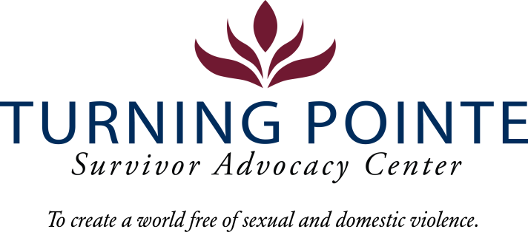
JOB DESCRIPTION
Job Title: Shelter Admin Assistant
Job Location: Shelton
Reports to: Program Director
Classification: Non-Exempt Full Time
Salary Range: $17 - $19 (DOQ)

Schedule: 8:00 am – 4:30 pm Monday – Friday (attendance at Thursday staff meetings, 2:30 pm – 4:30 pm is required) Note: Schedule may vary occasionally to include holiday shelter coverage (holiday payrate applies).

BENEFITS
- Accrued paid time off (PTO), eligible upon date of hire
- Employer funded Simple IRA, eligible upon date of hire
- Employer funded life insurance policy, eligible upon date of hire
- Medical/Vision/Dental Insurance, fully paid by employer
- Employer funded Health Savings Account (HSA)
- Paid 10 holidays and one personal day
- YMCA membership
- Mileage paid for work related activities above normal commute

WA state background, fingerprinting, and, federal sex offender database checks are required for employment.

Founded in 2001, Turning Pointe’s mission is to provide safety and support for survivors through advocacy, prevention education and action for social change. Our Advocates work with over 500 adult and youth survivors of domestic and sexual violence every year in our Shelton and Belfair, WA locations. We serve all survivors – we do not discriminate on the basis of gender identification, age, race, ethnicity, religion, marital status, nationality, disability or immigration status.

We place a high priority on the career development and wellness of every Turning Pointe team member. Employee recognition awards, staff retreats, celebratory potlucks, self-care activities and opportunities to grow professionally through special project assignments, expanded job responsibilities, conferences and training sessions are an important part of our culture.

POSITION SUMMARY
The Shelter Administrative Assistant team member is responsible for handling front desk duties including answering phones and directing calls to the appropriate staff member; welcoming clients, community partners and guests to the administrative offices/shelter; managing the acceptance of contributions and donations; support shelter residents and, handling select non-case management needs of clients. This position also performs general administrative, recordkeeping duties and, completes timely and accurate data entry as needed. Cleaning shelter common areas and living spaces and other tasks are required as assigned. At times this team member will back up Advocates by assisting with screenings when Advocates are in appointments or on the phone.

This position supports management with projects as needed, preparation for shelter-based client activities/special events, administrative involvement in select community outreach and fundraising events or, helping with planning of Turning Pointe staff training and team building events.
Turning Pointe Competencies
- Communication: Expresses ideas effectively in writing and verbally; shares ideas and information with others proactively; organizes and delivers information appropriately; style and content of communication is audience-specific; actively and empathetically listens.
- Teamwork: Interacts with people effectively; able and willing to share and receive information; cooperates within groups and across groups; supports group decisions and puts group goals ahead of own goals.
- Initiative: Generates innovative ideas for improvement and problem-solving; practices self-development; does more than required and takes advantage of new opportunities.
- Sense of urgency: Prioritizes responsibilities of role appropriately; demonstrates enthusiasm and energy in approaching job; consistently meets or exceeds goals; maintains high level of productivity and self-direction.

ESSENTIAL RESPONSIBILITIES, DUTIES AND TASKS

Administration and Client Services

- Provides support to Turning Pointe clients including, and not limited to, telephone-based and face/face reception duties, management of charitable in-kind donations, ensures completion and filing of confidentiality forms for guests and service providers
- Responsible for answering phones, taking messages, forwarding written requests and inquiries from the public, community members and clients to the appropriate Turning Pointe team member.
- Maintains files, folders and paperwork in receptionist area for Turning Pointe staff and guests including: in-kind donation receipts, confidentiality forms, release of information (ROI) forms, intake folders, CSRs, One Time Contacts, Shelter Screenings, and job applications
- Maintains kitchen cleaning schedule
- Cleans and maintains lobby and receptionist areas bright and welcoming
- Maintains Library in lobby
- Assist with putting away shelter and office supplies
- Coordinates with vendors, guests, and other visitors as needed
- Review and utilize Outlook calendars for shelter coordination
- Assists with “front of the house” tasks, such as shelter resident mailbox assignments, master whiteboard for shelter room assignments, laundry sign ups, food donation distribution and pantry replenishment
- Updates all client interactions in CSR’s
- Supports special events and staff professional development workshops, team building activities, community outreach and fundraising events as needed

Education and Experience
- GED or HS diploma required
- Two years receptionist, administrative/clerical experience, a plus
- One-year community service, social work or DV/SA advocacy experience, a plus

Minimum Qualifications

- Valid driver’s license and state required minimum automobile insurance coverage
- Current COVID-19 Vaccination Record Card
- Ability to interact professionally with diverse clients, staff, community members, civic leaders, first responders and law enforcement
- Strong verbal communication skills
- Basic proficiency in Microsoft Word, Excel, Outlook and other data management systems
- Ability to prioritize and multitask
- Ability to work a flexible schedule (including holidays), when needed, to support staffing requirements of 24/7 shelter
- Ability to remain calm in a fast paced-environment and be productive during down times

Physical Demands and Working Conditions
This position works in a fast-paced, crisis-oriented environment which can be emotionally taxing. Staff remain calm and often must deal with tense situations appropriately and immediately when interacting with clients, staff, community members, law enforcement and first-responders. Much of an employee’s time is spent providing face/face and phone-based client services as well as responding to individuals in crisis on hotline calls; time at a computer or performing other duties as needed is expected. The job often requires cleaning shelter rooms and moving personal belongings after a client leaves Turning Pointe. Employees must be able to lift or carry 15 – 30 pounds and push/pull 30 – 40 pounds. Position also requires being able to sit/stand for hours at a time.

Required Domestic Violence/Sexual Assault Advocate Core Training (Provided by Turning Pointe post-hiring)
- Minimum 50 hours of training and education
  - 30-hour Sexual Assault Core (WCSAP Approved)
  - 20-hour Domestic Violence Core (WSCADV Approved)
  - Or similar dual DV/SA Core Training (WCSAP/WSCADV Approved)

Employee Signature: ______________________________________ Date:

Turning Pointe is an equal opportunity employer committed to workplace diversity. We do not discriminate in employment practices based on age, sex, marital status, sexual orientation, race, creed, color, national origin, citizenship or immigration status, honorably discharged veteran or military status, or the presence of any sensory, mental, or physical disability or the use of a trained dog guide or service animal by a person with disability. (RCW 49.60.200)

