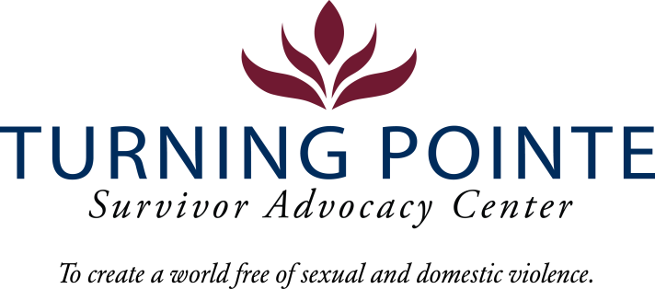
JOB DESCRIPTION
Job Title: Part Time Advocate – Weekends, On-Call
Job Location: Shelton
Reports to: Program Director
Classification: Non-Exempt Part Time (28 hours/week minimum +)
Salary Range: $17.50- 19.50/hour (DOQ)

Schedule: Saturdays & Sundays, 7am-7pm; Thursdays, 1:30 pm – 4:30 pm. Ability to pick up additional shifts as available.

Note: Schedule will vary occasionally to include holiday shifts (holiday payrate applies).

BENEFITS
- Accrued paid time off (PTO), eligible upon date of hire
- Employer contribution to Simple IRA, eligible upon date of hire
- Employer funded life insurance policy, eligible upon date of hire

WA state background, fingerprinting, and, federal sex offender database checks are required for employment.

Founded in 2001, Turning Pointe’s mission is to provide safety and support for survivors through advocacy, prevention education and action for social change. Our Advocates work with over 500 adult and youth survivors of domestic and sexual violence every year in our Shelton and Belfair, WA locations. We serve all survivors – we do not discriminate on the basis of gender identification, age, race, ethnicity, religion, marital status, nationality, disability or immigration status.

We place a high priority on the career development and wellness of every Turning Pointe team member. Employee recognition awards, staff retreats, celebratory potlucks, self-care activities and opportunities to grow professionally through special project assignments, expanded job responsibilities, conferences and training sessions are an important part of our culture.

POSITION SUMMARY
Advocates for survivors of domestic violence and sexual assault complete client screenings and intakes, provide phone-based and face/face advocacy as needed, support shelter residents, walk-in clients and remote/phone-based clients or hotline calls with referrals and information for appropriate resources including developing safety plans if appropriate. This position also performs general administrative and recordkeeping duties. Cleaning shelter common areas and living spaces and other tasks are required as assigned. The Weekend Advocate must be able to work independently, complete needed projects and meet the needs of clients with minimal supervision.

Turning Pointe Competencies
- Communication: Expresses ideas effectively in writing and verbally; shares ideas and information with others proactively; organizes and delivers information appropriately; style and content of communication is audience-specific; actively and empathetically listens.
- Teamwork: Interacts with people effectively; able and willing to share and receive information; cooperates within groups and across groups; supports group decisions and puts group goals ahead of own goals.
- Initiative: Generates innovative ideas for improvement and problem-solving; practices self-development; does more than required and takes advantage of new opportunities.
- Sense of urgency: Prioritizes responsibilities of role appropriately; demonstrates enthusiasm and energy in approaching job; consistently meets or exceeds goals; maintains high level of productivity and self-direction.

ESSENTIAL RESPONSIBILITIES, DUTIES AND TASKS

Administration and Data Entry
- Remaining knowledgeable of all Turning Pointe policies and procedures regarding client advocacy
- Maintaining current knowledge on community resources that support the needs of Turning Pointe’s clients
- Assisting in shelter cleanliness, organization, and donation sorting
- Accurately completing paperwork in a timely manner

General Advocacy and Client Relations
- Providing culturally appropriate advocacy support, resource materials and safety planning for Turning Pointe’s diverse clients as needed
- Recommending policies and or procedures to increase client safety, shelter housing, client confidentiality and advocate services
- Coordinating with Turning Pointe advocates and team members to enhance client support and services

Education and Experience
- GED or HS diploma required
- Associate’s degree or higher in social work or related field, a plus
- Two years community service, social work or DV/SA advocacy experience, a plus

Minimum Qualifications
- Valid driver’s license and state required minimum automobile insurance coverage
- Ability to travel independently, as needed, for professional events and work tasks
- Current COVID-19 Vaccination Record Card
- Ability to interact professionally with diverse clients, staff, community members, civic leaders, first responders and law enforcement
- Strong verbal communication skills
- Basic proficiency in Microsoft Word, Excel, Outlook and other data management systems
- Ability to prioritize and multi-task
- Ability to work a flexible schedule (including holidays), when needed, to support staffing requirements of 24/7 shelter

Physical Demands and Working Conditions
This position works in a fast-paced, crisis-oriented environment which can be emotionally taxing. Staff must always remain calm and often must deal with tense situations appropriately and immediately when interacting with clients, staff, community members, law enforcement and first-responders. Much of an Advocate’s time is spent providing face/face and phone-based client services as well as responding to individuals in crisis on hotline calls; time at a computer or performing other duties as needed is expected. The job often requires cleaning shelter rooms and moving personal belongings after a client leaves Turning Pointe. Employees must be able to lift or carry 15 – 30 pounds and push/pull 30 – 40 pounds. Position also requires being able to sit/stand for hours at a time.

Required Domestic Violence/Sexual Assault Advocate Core Training (Provided by Turning Pointe post-hiring)
- Minimum 50 hours of training and education
  - 30-hour Sexual Assault Core (WCSAP Approved)
  - 20-hour Domestic Violence Core (WSCADV Approved)
  - Or similar dual DV/SA Core Training (WCSAP/WSCADV Approved)

Employee Signature: ______________________________________ Date:

Turning Pointe is an equal opportunity employer committed to workplace diversity. We do not discriminate in employment practices based on age, sex, marital status, sexual orientation, race, creed, color, national origin, citizenship or immigration status, honorably discharged veteran or military status, or the presence of any sensory, mental, or physical disability or the use of a trained dog guide or service animal by a person with disability. (RCW 49.60.200)

