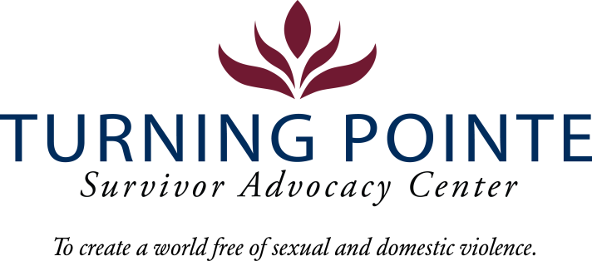
JOB DESCRIPTION
Job Title: Prevention Education Specialist (Bilingual Spanish preferred)
Job Location: Shelton/Mason County
Reports to: Youth and Prevention Lead
Classification: Non-Exempt, Full-time
Salary Range: $18.00 - $20.00/hour (DOQ)

Schedule: Proposed: 8:30 am – 5:00 pm Monday – Friday

Attendance at Thursday staff meetings, 2:30 pm – 4:30 pm, in Shelton offices is required.

Note: Schedule will vary occasionally to support events/trainings. Occasional evening and weekend work required.

BENEFITS
- Accrued paid time off (PTO), eligible upon date of hire
- Employer funded Simple IRA, eligible upon date of hire
- Employer funded life insurance policy, eligible upon date of hire
- Medical/Vision/Dental Insurance, fully paid by employer
- Employer funded Health Savings Account (HSA)
- Paid 11 holidays and one personal day
- Mileage reimbursement for work-required travel beyond typical commute

WA state background, fingerprinting, and, federal sex offender database checks are required for employment.

Founded in 2001, Turning Pointe’s mission is to provide safety and support for survivors through advocacy, prevention education and action for social change. Our Advocates work with over 500 adult and youth survivors of domestic and sexual violence every year in our Shelton and Belfair, WA locations. We serve all survivors – we do not discriminate on the basis of gender identification, age, race, ethnicity, religion, marital status, nationality, disability or immigration status.

We place a high priority on the career development and wellness of every Turning Pointe team member. Employee recognition awards, staff retreats, celebratory potlucks, self-care activities and opportunities to grow professionally through special project assignments, expanded job responsibilities, conferences and training sessions are an important part of our culture.

POSITION SUMMARY
The Prevention Education Specialist is responsible for a variety of tasks central to agency outreach, education, training and prevention programming on the topics of domestic violence and sexual assault. The primary goal of prevention education is to create opportunities for social change, community awareness and support, and increased knowledge on the topics of domestic violence and sexual assault. Prevention education lends itself to reducing domestic and sexual violence across Mason County and in surrounding areas.

Turning Pointe Competencies
- Communication: Expresses ideas effectively in writing and verbally; shares ideas and information with others proactively; organizes and delivers information appropriately; style and content of communication is audience-specific; actively and empathetically listens.
- Teamwork: Interacts with people effectively; able and willing to share and receive information; cooperates within groups and across groups; supports group decisions and puts group goals ahead of own goals.
- Initiative: Generates innovative ideas for improvement and problem-solving; practices self-development; does more than required and takes advantage of new opportunities.
- Sense of urgency: Prioritizes responsibilities of role appropriately; demonstrates enthusiasm and energy in approaching job; consistently meets or exceeds goals; maintains high level of productivity and self-direction.

ESSENTIAL RESPONSIBILITIES, DUTIES AND TASKS

Community Awareness:
- Coordinate strategic awareness campaigns, manage promotion, planning, implementation and evaluation of all activities to ensure high value-add to Turning Pointe and the organization’s resources are used effectively
- Develop a calendar of events, activities, presentations and trainings to share with the public
- Seek opportunities to speak at local clubs, businesses, organizations in Mason County to raise awareness of domestic violence and sexual assault and the services of Turning Pointe

Community Partnerships & Outreach:
- Develop and promote prevention education “menu” options to groups, schools, community partners and others
- Foster strong relationships with all school districts throughout Mason County
- Develop and maintain strategic partnerships with local organizations, communities, and relevant groups
- Assist with material distribution and outreach for Turning Pointe in Mason County and surrounding areas
- Attend local events where Turning Pointe’s services could be appropriately promoted

Prevention Education & Community Trainings:
- Remain up-to-date on the latest prevention and education requirements, best practices, research and strategies as it relates to the position and local schools
- Assist with updating Turning Pointe’s prevention goals and strategic planning for the program
- Develop and implement prevention programs in partnership with local organizations and communities
- Facilitate and lead prevention education opportunities in schools and other youth-serving organizations
- Assist with Turning Pointe’s youth leadership program
- Facilitate and lead Core DV/SA trainings quarterly or as needed
- Provide prevention-related trainings for staff & volunteers

Others Duties:
- Attend all required staff meetings and trainings
- Coordinate events with Youth and Prevention Lead
- Enter data into InfoNet as related to activities performed
- Help Program Coordinator recruit outside training opportunities for staff meetings as needed
- Submit quality materials to local newspapers, radio stations, and in-house newsletters for community awareness and education
- Other duties as assigned

Education and Experience
- Associate’s Degree in Education, Psychology or Marketing or related field, required
- Minimum of two years’ experience facilitating training and/or teaching

Minimum Qualifications
- Valid driver’s license, dependable car and state required minimum automobile insurance coverage
- Ability to travel independently, as needed, for professional events and work tasks
- Current COVID-19 Vaccination Record Card
- Ability to interact professionally with diverse staff, community members, civic leaders, first responders and law enforcement
- Strong verbal communication skills
- High level of proficiency in Canva, Microsoft Word, Excel, PowerPoint, Outlook
- Experience working with children and youth
- Ability to utilize virtual platforms to maximize reach
- Demonstrated ability to work with individuals with diverse cultural and social backgrounds

Physical Demands and Working Conditions
This position works in a fast-paced, crisis-oriented environment which can be emotionally taxing. Staff must always remain calm and often must deal with tense situations appropriately and immediately when interacting with clients, staff, community members, law enforcement and first-responders. Employees must be able to lift or carry 15 – 30 pounds and push/pull 30 – 40 pounds. Position also requires being able to sit/stand for hours at a time.

Required Domestic Violence/Sexual Assault Advocate Core Training (Provided by Turning Pointe post-hiring)
- Minimum 50 hours of training and education
  - 30-hour Sexual Assault Core (WCSAP Approved)
  - 20-hour Domestic Violence Core (WSCADV Approved)
  - Or similar dual DV/SA Core Training (WCSAP/WSCADV Approved)

Employee Signature: ______________________________________ Date:

Turning Pointe is an equal opportunity employer committed to workplace diversity. We do not discriminate on the basis of gender identification, age, race, ethnicity, religion, marital status, national origin, disability or veteran status.

